**How to download and install LoadRunner for free**

The installation of LoadRunner is pretty straightforward. HP allows you to **download a free community edition of LoadRunner**. This edition allows one to run 50 virtual users. It also allows you to run multiple protocols except for the DCOM and GUI protocol.

In this tutorial, you will learn the following:

1. LoadRunner System Requirements
2. How to download LoadRunner
3. Installation – How to install LoadRunner
4. LoadRunner License Setup

**LoadRunner System Requirements**

The minimum requirements for LoadRunner are given below

|  |  |
| --- | --- |
| **Component** | **Minimum Requirement** |
| Processor speed | 1.6 GHZ or faster |
| Operating system | Works on:  Windows Server 2008 R2 SP1 64-bit  Windows Server 2012 64-bit [only supported for Controller and Analysis]  Windows 7 SP1 32 (supported) or 64-bit (recommended)  Windows 8 64-bit |
| Memory (RAM) | Minimum : 2 GB  Recommended : 4 GB or higher |
| Screen resolution | Minimum : 1024 x 768 |
| Browser | Microsoft Internet Explorer 8, 9 and 10 |
| Available hard disk space | Minimum : 40 GB |

**How to download LoadRunner**

Step1) To download the community edition, just go to the URL – <http://www8.hp.com/us/en/software-solutions/loadrunner-load-testing/try-now.html>

Once you have opened the URL in the browser, go to the Free Download section and click the Download Now button.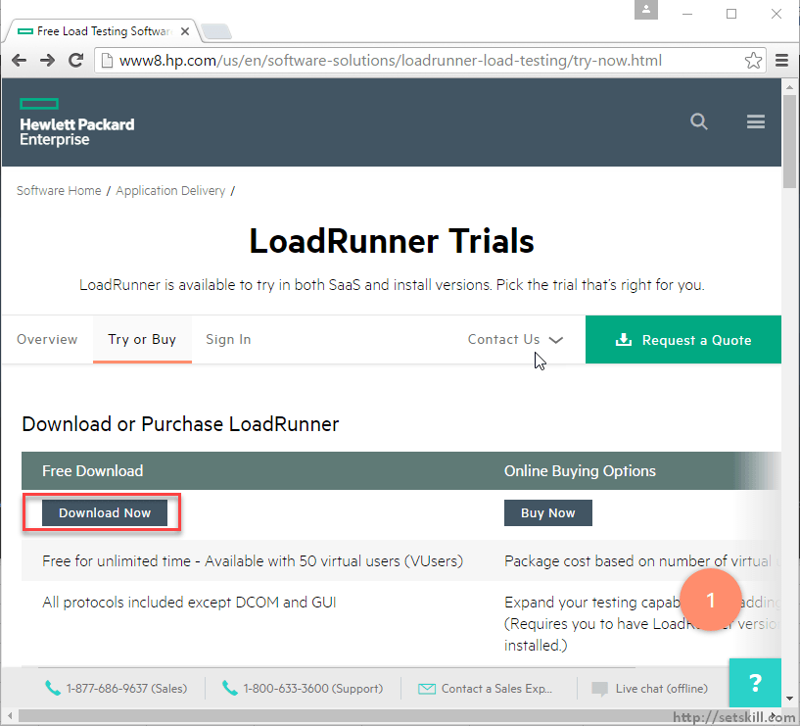

Step 2) After clicking the download button, you will be instructed to sign-up first. Enter the required information in the next screen and complete the necessary sign-up procedures.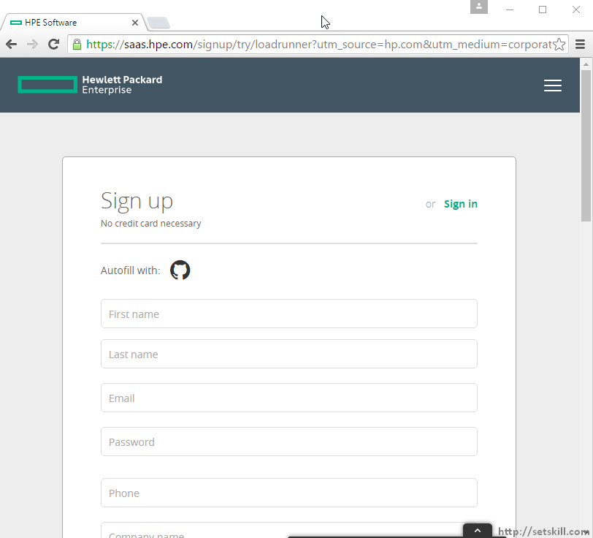

Once you complete entering the required information, you will see the Sign-up button. Click the button to proceed.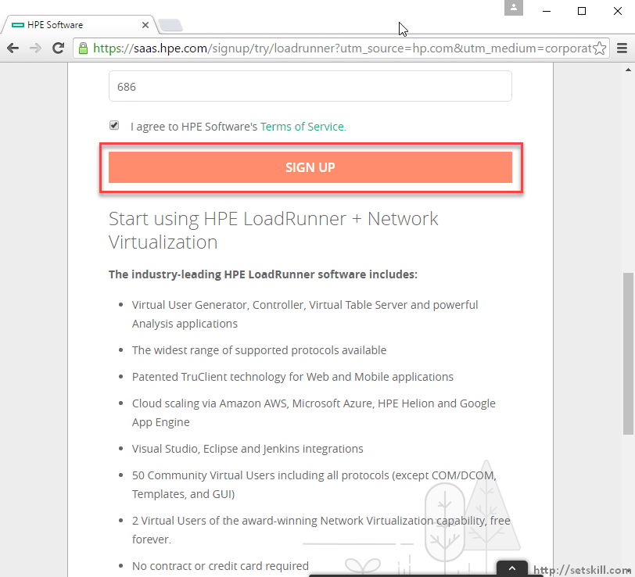

You will receive an email to complete the registration process. Once you complete the process, you will login in with your credentials and will now be able to see the Download button for the LoadRunner product.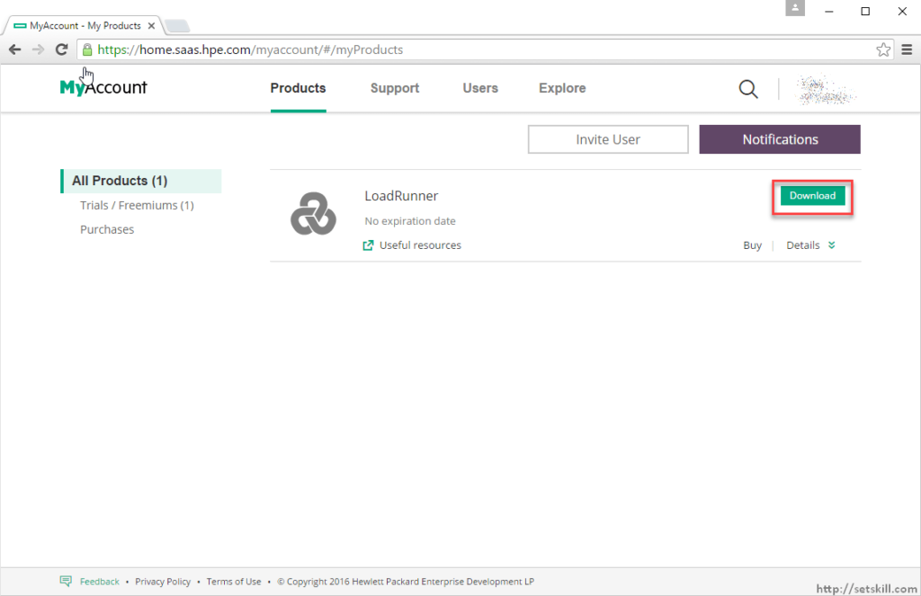

**Installation – How to install LoadRunner**

Now that you have downloaded the product, the next step is to install the LoadRunner product. Let’s review the steps in the installation process.

1. Click the Setup icon which is present in the LoadRunner installation file setup.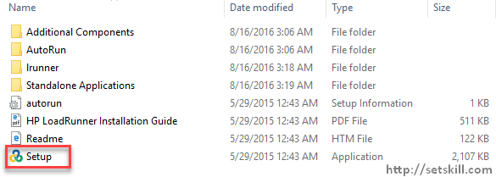
2. You will then be presented with a splash screen. You can choose the install the individual components if required. For the purpose of this tutorial, let’s choose to install the LoadRunner Full setup.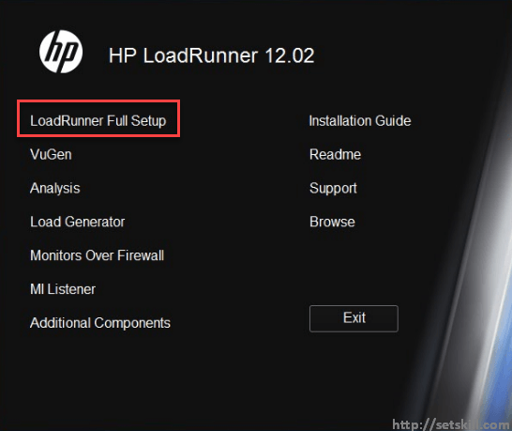
3. In the next screen, click on the next button to proceed.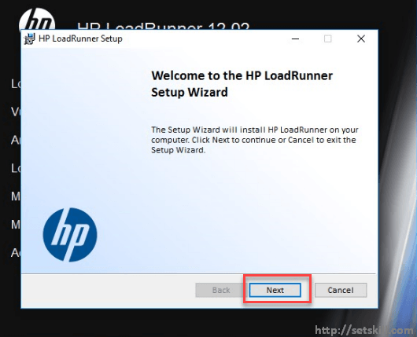
4. In the next screen, Accept the License Agreement and click on the Install button to proceed.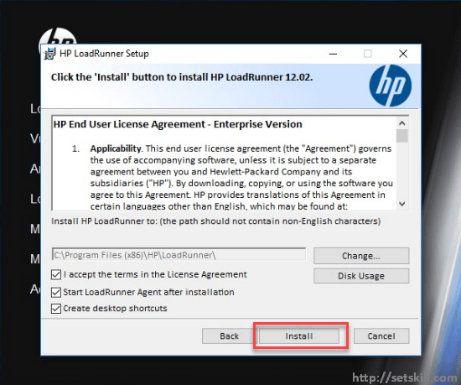
5. In the next screen, the setup will present the user with the pre-requisite software which needs to be installed. The pre-requisite software which needs to be installed will depend from system to system. Click the OK button to proceed.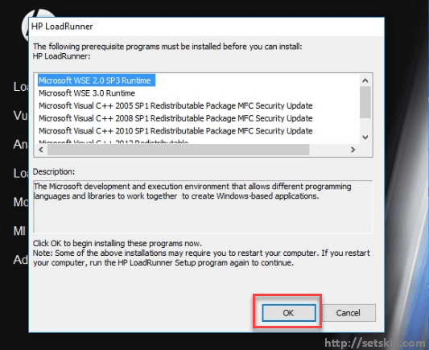Please note that the system will prompt for a restart for some of the pre-requisite software installation.
6. Once the installation is complete, the certificate screen will pop up. Since we don’t want to use any SSL certificates as of now, let’s uncheck the “Specify a certificate that will be used by the LoadRunner Agent” option and click on the Next button.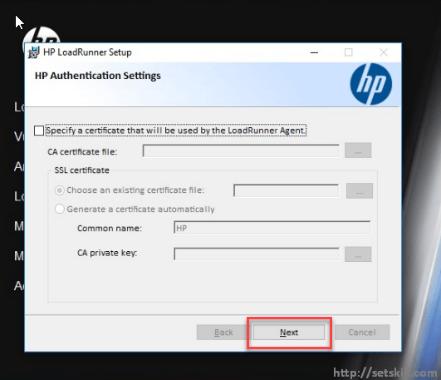
7. Once the setup is complete, click on the Finish button.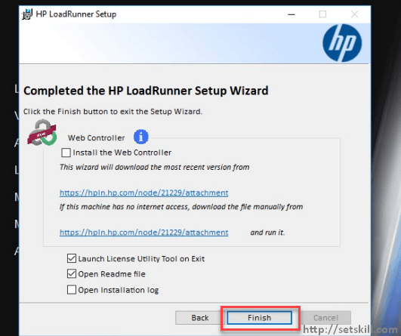

**LoadRunner License Setup**

The License utility will automatically launch after you click Finish in the previous step. You will notice that indeed you have 50 free virtual users which you can use for LoadRunner.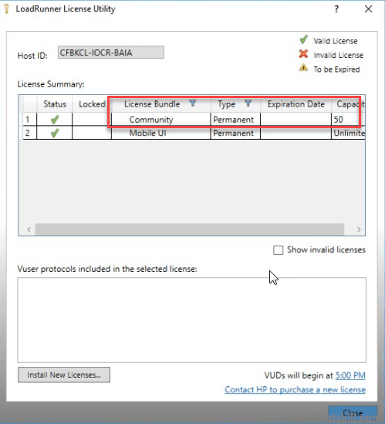

If you don’t have any licenses and wish to just use the Community edition licenses, just click on the Close button.

Note: With regards to the community edition license, the good news is that this license never expires. The only limitation is that you can only run 50 virtual users when conducting a load test.

If you do have proper licenses from HP, you can click on the Install New Licenses button. Click the Browse button and browse for the license file to apply the appropriate license, as shown below.